FS40+FS80 Pivot Bracket

Unified pivot bracket for FS40 and FS80
Version 1.0

Project Goals
- Merge the FS40 and FS80 Pivot bracket into 1 single project to simplify the usage.
- Add also a pivot bracket for FS10

Components: 4mm Knob
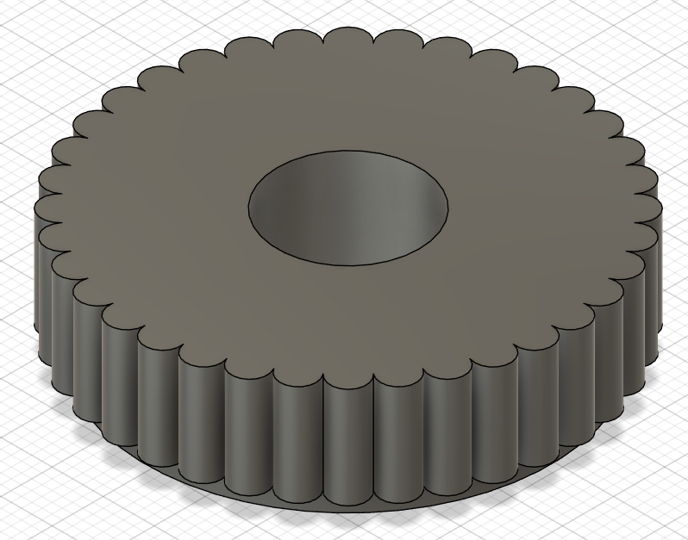

Components: FS40+FS80 Pivot Shoulder

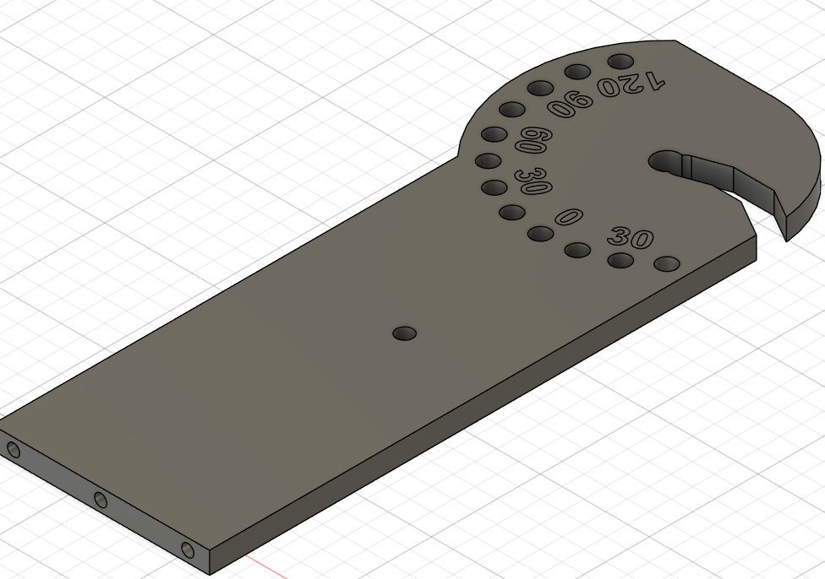

FS40 Unified Adapter

FS40 Unified Adapter 2MPix
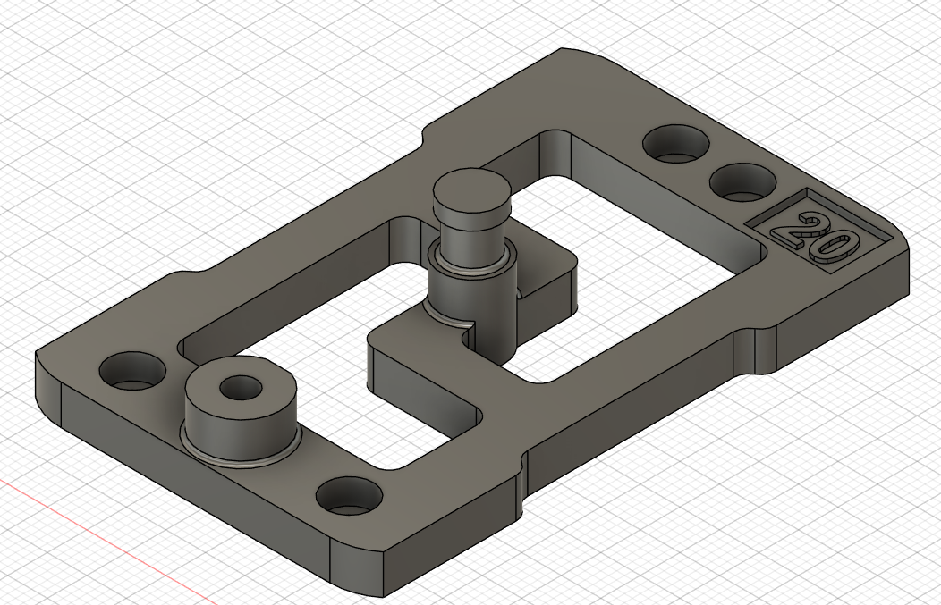

FS40 Unified Adapter 5MPix
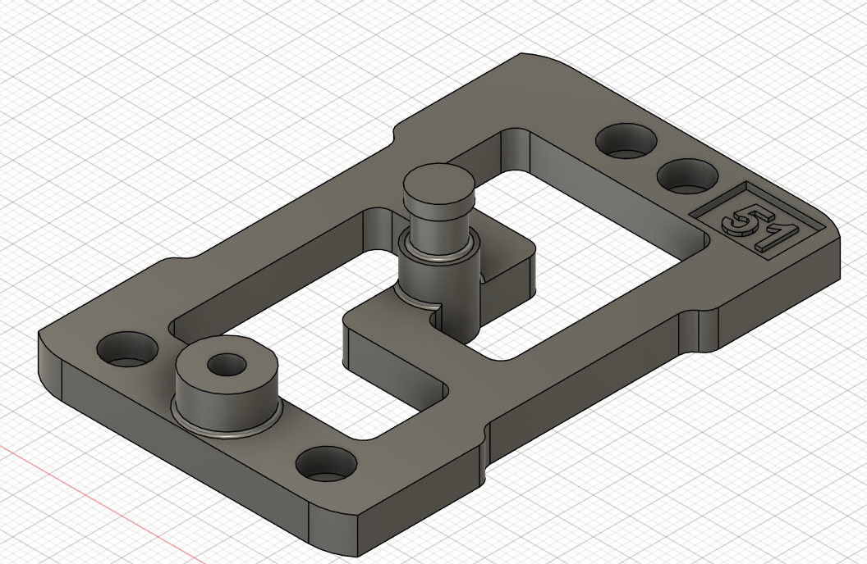

Components: FS80 Pivot Base v5
Base dimensions: 90x50 mm
Thickness: 5 mm
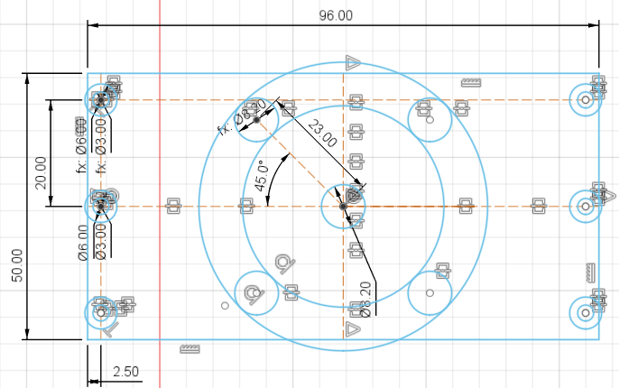

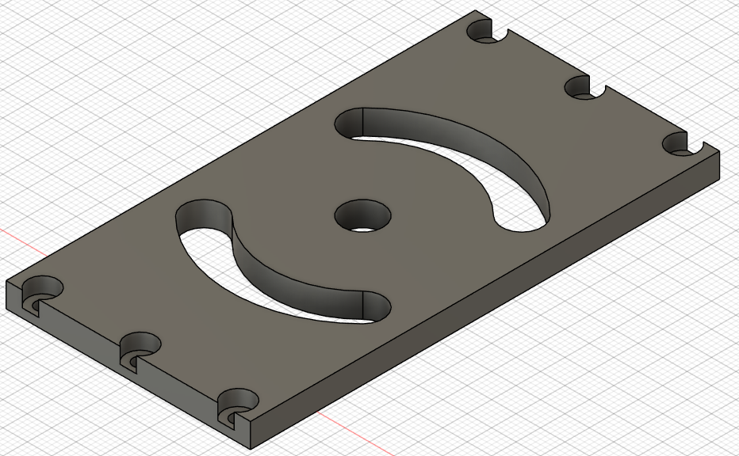

FS80 Unified Adapter
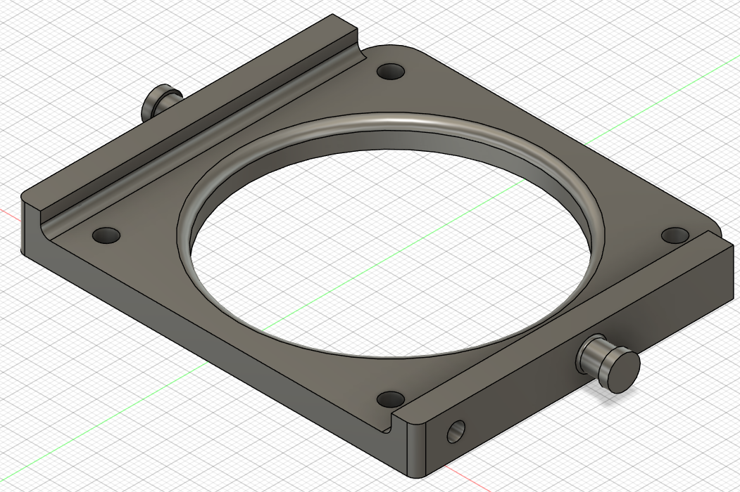

Camera drawings
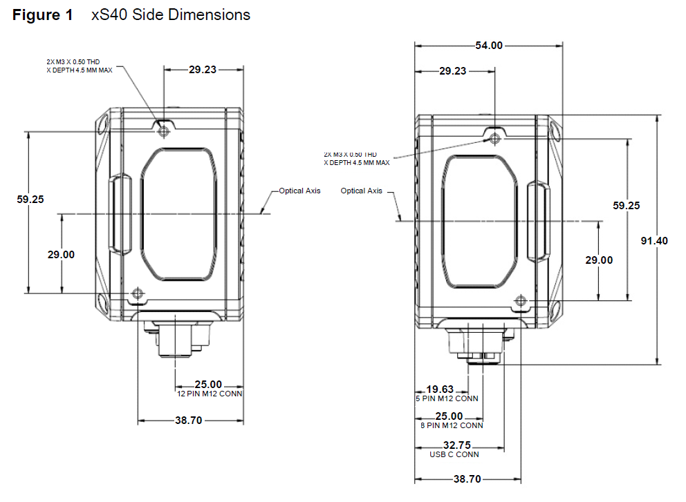

Adapter Plate
This plate is to connect to the camera side to the bracket creating a hinge centered around the camera optical axis

The bracket is symmetric and has twice the needed M3 holes just to use the same plate on both sides.

FS10 Adapter
